There’s No Room For Tension In A Self-Isolating Household

The pandemic has been hard, especially on families isolating at home. In fact, it’s not rare to hear of tension in households caused by boredom, restlessness, and the many stresses that come with such a difficult time. While this tension is something that can’t be avoided entirely, there are ways to ease the strain. CrossFit Madison Heights offers recommendations to make this time at home with your family a more harmonious one.

Follow a routine.

With COVID-19, everything is at a standstill. Because of this uncertainty, it’s more important than ever to maintain structure in your life and home. As Medium notes, a healthy routine, therefore, will not only provide the much-needed consistency that helps keep your family grounded, but it’s also a wonderful way for everyone to stay productive and focused. Routine tasks come with other benefits as well. For example, decluttering and cleaning your home can foster positivity and reduce stress. These tasks are especially important because they help create a home that's healthy for the mind as well as the body.

Kids who are currently learning at home definitely benefit from a routine. It can be a challenge to get your kids to take their education seriously when they’re stuck at home. However, the right amount of structure can help create an appealing learning environment. So go ahead and encourage early bed- and wake-up times, as well as follow a daytime schedule that includes breaks and playtime.

Structure will also serve you when you’re working from home. This is actually a great way to set boundaries so you can better focus on your tasks. Moreover, it’s also an effective way to keep burnout at bay. A morning routine is especially crucial as it sets the tone for your day, plus it gives you time to do things outside of work, such as exercise (book a session with CrossFit Madison Heights), meditation, or chores.

Give each other space.

Social distancing is a must in the pandemic. What most people don’t realize is that, from time to time, it’s also a must inside the home. Boundaries are important when family members are working or learning from home, but it should not be limited there. Parents are also entitled to ‘me’ time. Huffington Post points out that you might have to get creative to pull it off, but it can be done.

It should not be all work and no play for kids, as well. They need to have space and opportunities for play and the activities they love, too. Here’s a parenting hack: there are plenty of activities that are both enjoyable and educational, such as arts and crafts, science experiments, etc. With a few choice materials, your kids can be engaged for hours yet—in turn, giving you time for your own self-care.

Share the fun.

Boredom is arguably the biggest cause of household tension in the pandemic. The best thing you can do, therefore, is to have fun as a family, even when you’re stuck at home. For instance, playing online games like Fortnite will likely appeal to everyone in the family, regardless of age, so it’s a great idea to make it a part of your family routine. However, it’s only fun when you can download at a faster rate and maintain smooth gameplay. To make sure that your internet connection can handle the load, consider upgrading to fiber so everyone can enjoy a seamless experience—and you avoid adding the frustration of lagging downloads to your home.

The home remains your safest harbor in this pandemic, so it’s necessary for both parents and kids to adjust to life in isolation for the time being. With a solid routine and boundaries, as well as time to kick back and have fun, there’s no reason why you can’t make it work and kick household tension to the curb.

Whether you're a beginner or advanced, you can benefit from the CrossFit Madison Heights exercise program. To schedule a session, contact us at 434-401-8018.

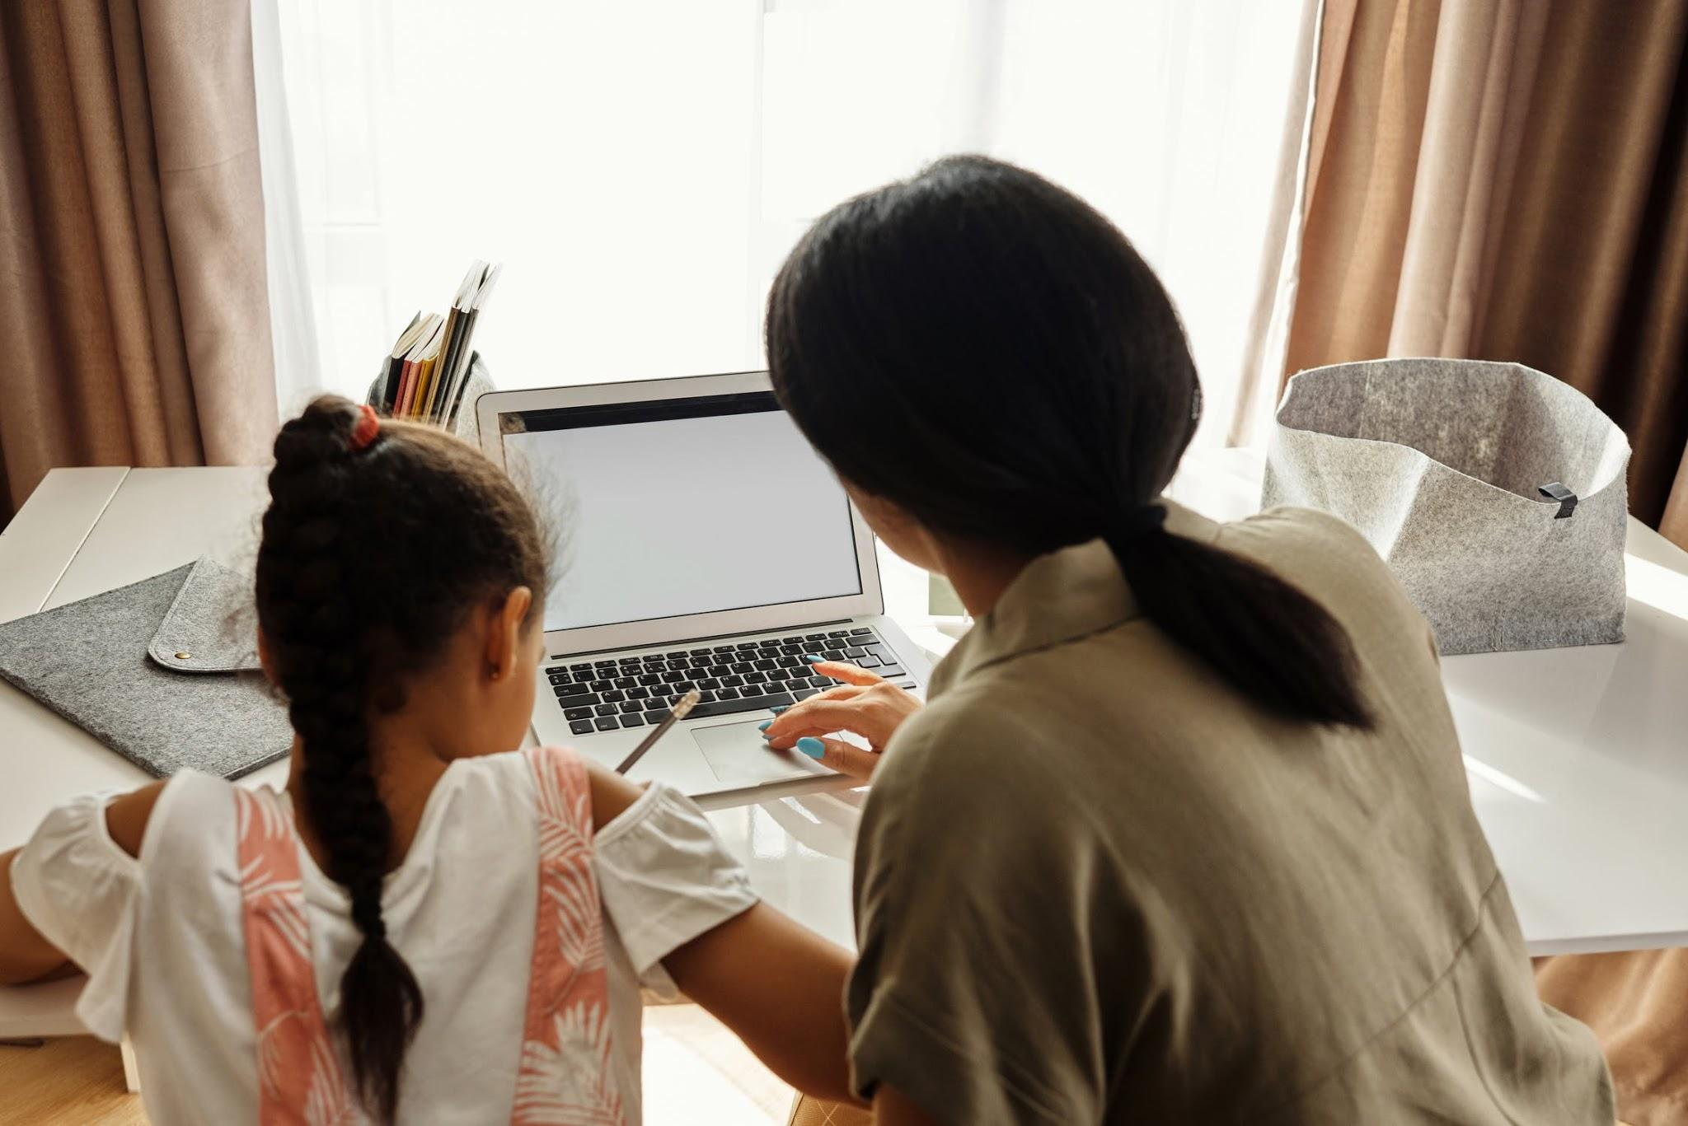

Photo via Pexels.com

